ETL Pipeline Documentation: Google Cloud Automation

1. Overview
This document describes the ETL pipeline that automates data extraction from Google Sheets, stores it in Google Cloud Storage (GCS) as Parquet files, and loads it into BigQuery (GBQ). The process is orchestrated using Cloud Functions, Pub/Sub, and Cloud Scheduler.

2. Architecture Diagram
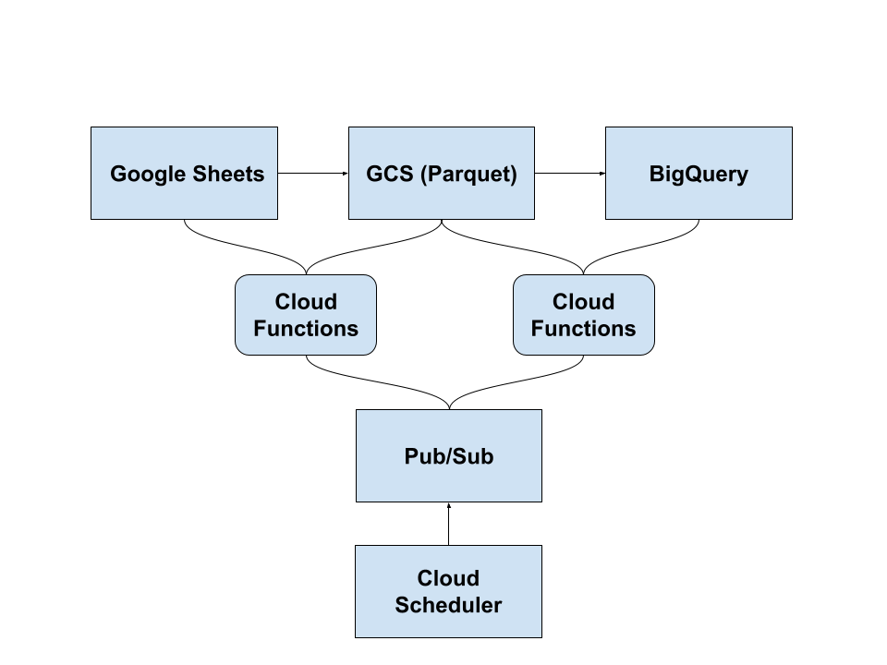

3. Components & Services Used
- Google Sheets – Source of raw data.
- Google Cloud Storage (GCS) – Temporary storage for extracted data in Parquet format.
- BigQuery (GBQ) – Destination for structured data storage and analysis.
- Cloud Functions – Automates data extraction and loading.
- Pub/Sub – Message queuing system to trigger Cloud Functions.
- Cloud Scheduler – Schedules and triggers the ETL pipeline at defined intervals.
- Looker Studio – Used for data visualization and reporting.

4. ETL Pipeline Steps

Step 1: Extract Data from Google Sheets
- A Cloud Function fetches data from a specific Google Sheet using the Google Sheets API.
- The extracted data is saved as a Parquet file in a specified GCS bucket.

Step 2: Load Data into Google Cloud Storage (GCS)
- The Parquet file is uploaded to GCS under a designated folder (e.g., raw-data/).
- Cloud Functions handle the upload process and file naming conventions.

Step 3: Load Data into BigQuery (GBQ)
- Cloud Function reads the Parquet file from GCS and loads it into a predefined BigQuery table.
- Schema mapping and data type validation are handled during this process.

5. Automation Workflow

Triggering Mechanism
- Cloud Scheduler runs at a specified frequency (e.g., daily at 12:00 AM).
- It triggers a Pub/Sub Topic, which then invokes the Cloud Function.

Cloud Functions Execution
- Function 1: Extraction & Storage
  - Reads Google Sheets data → Saves Parquet file to GCS.
- Function 2: Load to BigQuery
  - Reads Parquet file from GCS → Loads into BigQuery.

6. Deployment Guide

Prerequisites
- Enable the following APIs:
  - Google Sheets API
  - Cloud Functions
  - Pub/Sub
  - BigQuery
  - Cloud Storage
- Set up a Google Cloud Project and service account with necessary permissions.

Cloud Function: Extract , Upload to GCS (Parquet Format) & Load GCS Data to BigQuery (Parquet Format)
import base64
import functions_framework
import gspread
import pandas as pd
import json
import datetime
import re
from google.oauth2.service_account import Credentials
from google.cloud import bigquery, storage

# Constants
BUCKET_NAME = "gsheet-to-gcs"
FOLDER_NAME = "parquet_files"
PROJECT_ID = "gsheet-to-gbq"
DATASET_ID = "gcloudtask"
TABLE_NAME = "datafromgsheet"
LAST_ROW_FILE = "last_processed_row.json" # Stores last processed row index

# ✅ Function to get the last processed row count
def get_last_processed_row(storage_client):
bucket = storage_client.bucket(BUCKET_NAME)
blob = bucket.blob(LAST_ROW_FILE)

if blob.exists():
try:
row_data = json.loads(blob.download_as_text())
return row_data.get("last_processed_row", 0) # Default: 0 rows
except json.JSONDecodeError:
print("⚠️ Row count file is corrupted. Resetting.")
return 0
return 0 # First-time run

# ✅ Function to update last processed row count
def update_last_processed_row(storage_client, row_count):
bucket = storage_client.bucket(BUCKET_NAME)
blob = bucket.blob(LAST_ROW_FILE)
blob.upload_from_string(json.dumps({"last_processed_row": row_count}))
print(f"✅ Last processed row count updated: {row_count}")

# ✅ Cloud Function Trigger
@functions_framework.cloud_event
def hello_pubsub(cloud_event):
print(base64.b64decode(cloud_event.data["message"]["data"]))

# Google Sheets Authentication
SCOPES = ["https://www.googleapis.com/auth/spreadsheets.readonly", "https://www.googleapis.com/auth/drive"]
creds = Credentials.from_service_account_file("gsheet-to-gbq-971523a8b943.json", scopes=SCOPES)
client = gspread.authorize(creds)

try:
# Open Google Sheet
spreadsheet = client.open_by_url("https://docs.google.com/spreadsheets/d/1qrhCAybB4b5jxz7mr-NgdN8zVTdTn8NDVn8mnIG-SQ4")
worksheet = spreadsheet.sheet1
print("✅ Google Sheets connected successfully.")

# Convert Sheet data to Pandas DataFrame
data = worksheet.get_all_records()
df = pd.DataFrame(data)

if df.empty:
print("⚠️ No data found in the Google Sheet.")
return

print(f"📊 Loaded {len(df)} rows from Google Sheet.")

except Exception as e:
print(f"❌ Error loading data from Google Sheets: {e}")
return

# ✅ Clean column names for BigQuery compatibility
def clean_column_name(name):
name = name.strip().lower()
name = re.sub(r"[^a-zA-Z0-9_]", "_", name)
name = re.sub(r"_+", "_", name)
return name

df.columns = [clean_column_name(col) for col in df.columns]

# ✅ Convert `tac` column and others to STRING
for col in df.columns:
if df[col].dtype in ['int64', 'float64']:
df[col] = df[col].astype(str) # Ensure all numeric columns are stored as strings

# ✅ Get last processed row count
storage_client = storage.Client()
last_processed_row = get_last_processed_row(storage_client)

# ✅ Find new rows based on row index
if len(df) > last_processed_row:
df_new = df.iloc[last_processed_row:] # Select only new rows
else:
print("✅ No new rows to process. Exiting.")
return

print(f"📌 New rows detected: {len(df_new)}")

# ✅ Update last processed row count
latest_row_count = len(df)
update_last_processed_row(storage_client, latest_row_count)

# ✅ Save only new rows as a Parquet file
timestamp = datetime.datetime.now().strftime('%Y%m%d_%H%M%S')
parquet_file_name = f"{FOLDER_NAME}/gsheet_data_{timestamp}.parquet"
local_parquet_file = f"/tmp/{parquet_file_name.split('/')[-1]}"

try:
df_new.to_parquet(local_parquet_file, engine="pyarrow")
print(f"📂 Data saved locally as Parquet: {local_parquet_file}")
except Exception as e:
print(f"❌ Error saving Parquet file locally: {e}")
return

# ✅ Upload only new rows as Parquet file to Google Cloud Storage
try:
bucket = storage_client.bucket(BUCKET_NAME)
blob = bucket.blob(parquet_file_name)
blob.upload_from_filename(local_parquet_file)

print(f"✅ Parquet file uploaded to GCS: gs://{BUCKET_NAME}/{parquet_file_name}")

except Exception as e:
print(f"❌ Error uploading Parquet file to GCS: {e}")
return

# ✅ Load only new rows into BigQuery
bq_client = bigquery.Client()
full_table_id = f"{PROJECT_ID}.{DATASET_ID}.{TABLE_NAME}"

print(f"📌 Loading data into BigQuery Table: {full_table_id}")

try:
# ✅ Explicit schema definition to prevent type mismatch
schema = [
bigquery.SchemaField("tac", "STRING"), # Ensure `tac` is always STRING
# Add other fields as needed:
# bigquery.SchemaField("column_name", "INTEGER"),
# bigquery.SchemaField("another_column", "FLOAT"),
]

job_config = bigquery.LoadJobConfig(
source_format=bigquery.SourceFormat.PARQUET,
write_disposition=bigquery.WriteDisposition.WRITE_APPEND, # Append new data
schema=schema, # Apply schema explicitly
)

load_job = bq_client.load_table_from_uri(
f"gs://{BUCKET_NAME}/{parquet_file_name}", full_table_id, job_config=job_config
)
load_job.result()

print(f"✅ Data successfully loaded into BigQuery table: {full_table_id}")

except Exception as e:
print(f"❌ Error loading data into BigQuery: {e}")

7. Monitoring & Logging
- Cloud Logging: Logs are stored in Google Cloud Logs for debugging.
- Cloud Monitoring: Track execution times, errors, and function invocations.
- Error Handling: Retry policies in Pub/Sub for failed executions.

8. Visualization in Looker Studio
- Connect Looker Studio to BigQuery.
- Create basic charts (e.g., bar charts, line charts, tables).
- Use filters for better insights.

9. Future Enhancements
- Add data validation before loading into BigQuery.
- Implement transformations using dbt or BigQuery SQL.
- Optimize performance using partitioning and clustering in BigQuery.

